Herzberg's Two Factor Theory of Motivation.

The two-factor theory developed from data collected by Herzberg in 1964 from interviews with 203 engineers and accountants in the Pittsburgh area, chosen because of their professions' growing importance in the business world.

Herzberg was the first to show that satisfaction and dissatisfaction at work nearly always arose from different factors.
- There are factors that a business can introduce to make people work harder [known as motivators or job satisfiers] – more responsibility, range of tasks to perform.

- There are factors that would demotivate an employee if not present – job dissatisfiers [but would not necessarily make them work harder] eg pay and working conditions – poor toilets.
It is important to note that Herzberg says the factors which motivate people at work are different to and not simply the opposite of the factors which cause dissatisfaction eg if you create a healthy environment but do not provide members of the team with any motivators they will still be dissatisfied.

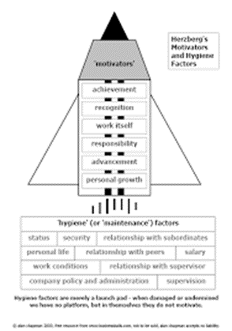

According to Herzberg, individuals are not content with the satisfaction of lower-order needs at work; for example, those needs associated with minimum salary levels or safe and pleasant working conditions. Rather, individuals look for the gratification of higher-level psychological needs having to do with achievement, recognition, responsibility, advancement, and the nature of the work itself. However, Herzberg added a new dimension to this theory by proposing a two-factor model of motivation, based on the notion that the presence of one set of job characteristics or incentives leads to worker satisfaction at work, while another and separate set of job characteristics leads to dissatisfaction at work. Thus, satisfaction and dissatisfaction are not on a continuum with one increasing as the other diminishes, but are independent phenomena.
This theory suggests that to improve job attitudes and productivity, managers must recognize and attend to both sets of characteristics and not assume that an increase in satisfaction leads to decrease in dissatisfaction.
According to the Two-Factor Theory, there are four possible combinations:^{[8]}
- High Hygiene + High Motivation: The ideal situation where employees are highly motivated and have few complaints.
- High Hygiene + Low Motivation: Employees have few complaints but are not highly motivated. The job is viewed as a paycheck.
- Low Hygiene + High Motivation: Employees are motivated but have a lot of complaints. A situation where the job is exciting and challenging but salaries and work conditions are not up to par.
- Low Hygiene + Low Motivation: This is the worst situation where employees are not motivated and have many complaints.

Herzberg thought it was important to eliminate job dissatisfaction before going onto creating conditions for job satisfaction because it would work against each other.
Herzberg believed that businesses should motivate employees by adopting a democratic approach to management and by improving the nature and content of the actual job through certain methods. Some of the methods managers could use to achieve this are:
- Job enlargement – workers being given a greater variety of tasks to perform (not necessarily more challenging) which should make the work more interesting.
- Job enrichment - involves workers being given a wider range of more complex and challenging tasks surrounding a complete unit of work. This should give a greater sense of achievement.
- Empowerment means delegating more power to employees to make their own decisions over areas of their working life.

