Careerpilot – supporting subscribing universities in mitigating risks identified by the Office for Students.
For those completing new APPs for 24 onwards and those that will complete the new APP in 25 onwards
Summary of document:
This document explain how Careerpilot can support your APPs. Just use what suits your needs. The document references how Careerpilot can support collaboration (page 3) and how it can support your plans to mitigate risks, specifically:
- Risk 1: Skills and Knowledge,
- Risk 2: Information and Guidance,
- Risk 3: Perceptions of HE.
Page 1 and 2 includes information about Careerpilot and survey data from users.
Page 3 – 8 shows how Careerpilot supports collaboration and can help mitigate each of the risks, with a described activity, outputs and outcomes.
Page 9-10 has a Theory of Change
Page 11 has evidence that careers support attainment.
Page 13 has the indicators of attainment we will assess impact against.

Careerpilot explained:
Careerpilot is an award-winning (CDI), one-stop career site that supports 11-19 year olds in exploring, choosing and planning their next stage progression. The site provides information, advice and tools that help students explore job/course options linked to their values, subjects they love, skills, etc. and through a three-stage career-decision process that coaches them through getting to know themselves, exploring their options and in making a progression plan. Students register on the site and can then build their Career Tool’s report, which moves up with them annually until they are 20.
The site also includes a Parent Zone, Reporting Zone, Adviser Zone and the Pathway Planner triage model and tool –that supports students in choosing their next stage pathways, assesses their readiness to progress and creates data so that schools can intervene and support an individual student in preparing for effective progression.
Careerpilot is a complete careers package, providing students, schools, parents and advisers with a single source of information and advice to support student progression, and helping schools to meet the Gatsby Benchmarks. The website is managed and populated by qualified and practicing career advisers. The team is hosted at and managed by the University of Bath on behalf of the subscribing consortium.
The site was developed in 2011, through a collaboration of subscribing universities in the SW. Subscriptions from a consortium of universities, Uni Connects and Careers Hubs enables the site and all web tools to be offered free to all students, schools and Uni Connects in the SW and some of the SE regions.
Reach:
The site had 549,000+ users in 2022-23, with over 260,000 students creating accounts on the site to build their Career Tool report, of these 138,000+ are in the SW region.
There are 640 schools who are engaged in using Careerpilot, with 130 meeting all our criteria of effective use and becoming Super Users.
Evidence of the impact of Careerpilot on students and school staff:
Careerpilot has been part of two research projects assessing its impact on young people.
These research projects have demonstrated that Careerpilot:
- Increases understanding of the importance of exploring ideas and forward planning;
- Broadens awareness of educational pathways and knowledge of higher education;
- Increases understanding of future career ideas and graduate employment;
- Develops confidence in self and future ideas;
The whole-school personal guidance approach has supported schools’ achievement of Gatsby Benchmark 8 ‘Personal Guidance’. It has also helped schools move towards achieving Gatsby Benchmarks 1, 2, 3, 4 and 7.
https://careerpilot.org.uk/assets/file/a905c312-b197-43a7-8dca-f66545823a0f/final-careerpilot-win-executive-summary-aug-2019.pdf
https://careerpilot.org.uk/assets/file/37ad257d-2af8-46a8-8820-8ae17da71cb8/executive-summary-final-cec-careerpilot-pathway-planner-june-2020-v-2.pdf
Online users survey:
An online survey is used to evaluate the impact of Careerpilot on young people, which users choose to complete.
The survey assesses what students are using, what they have learnt, what they will do as a result of using Careerpilot. From September 2023 the survey will also assess whether using Careerpilot has impacted on indicators linked to career skill development and attainment.
Since September 2020, 2685 young people have completed the Careerpilot online survey, which shows:
- 96% of users said the site was useful,
- 92% said it helped them understand more about their range of options,
- 83% found out more about HE,
- 75% said they learnt that ‘uni level could be a choice for me’,
- 74% said they learnt ‘about the range of providers offering post16/18 courses, including at a higher level,
- 63% said they felt more able to make choices after using the site,
- 85% said they learnt that ‘achieving the best qualifications I can will give me more choices in working life’
- 64% said they felt more able to make decisions after using Careerpilot
Staff survey:
An annual survey of 31 staff using Careerpilot in schools shows:
- 97% found the information on jobs, which includes pathways into them useful;
- 100% agreed that Careerpilot:
- met its planned aim to provide young people with information about the full range of choices;
- provides information that is relevant;
- supports young people in developing an awareness of the link between academic achievement and options for future jobs/careers;
- provides ‘Career Tool’s that help young people learn about themselves, their options and support the decision-making process;
- helps them meet the following Gatsby Benchmarks in some way:
- Gatsby Benchmark 1 to have a stable careers programme;
- Gatsby Benchmark 2: Learning from Labour Market Information,
- Gatsby Benchmark 4: Linking curriculum to careers, in some way.
- 96% also said Careerpilot helps them meet Gatsby Benchmark 3: Addressing the needs of every pupil, in some way

How Careerpilot supports collaboration:

The OFS states:
A provider should consider, where appropriate, agreeing an intervention strategy and related expected outcomes in collaboration with other providers and third sector organisations.

Careerpilot is a one-stop careers platform that supports young people through the career exploration, planning and progression process and provides additional resources and tools to help those that support young people e.g. parents, schools and Uni Connects.
Through the collaboration, a consortium of universities, Uni Connects and some Careers Hubs in the SW and SE provide annual subscriptions and on-going support to ensure through Careerpilot, all young people (11-19), in the SW, can access impartial, relevant and high-quality, information, advice and guidance.

The collaborative funding also supports young people nationally through providing free access to the main student-focused area of the site.
Careerpilot is also part of a collaborative strategy to engage underrepresented groups through other widening participation intervention services, such as, Virtual Schools who work with children in care and through Into University, Uni Connects and a project working with Home Educated young people and parents.
An analysis through the HEAT Tracker of the postcodes of registered students in 22-23 shows a significant percentage are from disadvantaged groups:
- 33% are from IMD Q1 or Q2
- 48% from TUNDRA Q1 or Q2
- 42% from POLAR Q1 or Q2
- 33% from IDACI Q1 or Q2

How Careerpilot can help mitigation of risks as identified by the OFS in the EORR
Your subscription to Careerpilot as an HEI has a direct impact on mitigating some of the risks identified by the Office for Students in the EORR.
You can use the information below when completing your APP to show how your subscription to Careerpilot is helping you address some of the risks.
See Theory of Change Appendix 1
Links to research evidence that shows the impact of Careerpilot on students or more generic evidence of the impact of careers on attainment is available in the sub-section ‘Evidence’ Appendix 2.
If you would like any of this information in a different format then please contact sl200@bath.ac.uk.
The main risks that Careerpilot contributes to are in the ‘access’ category.
Careerpilot can help to mitigate several of the risks identified through the EORR but it specifically helps to mitigate the risks below, probably in this priority order:
- Risk 2: Information and guidance
- Risk 3: Perception of higher education
- Risk 1: Knowledge and skills
Careerpilot can help mitigate these risks as follows:
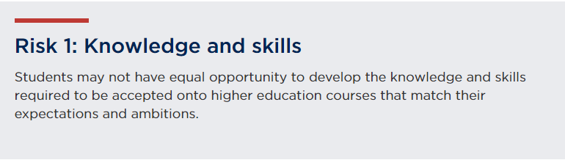
Research shows the link between good career education information, advice and guidance (CEIAG) and attainment, see Appendix 2 for links to research evidence.
In summary, the evidence shows that Careers Education, Information, Advice and Guidance (CEIAG) can support attainment indicators, as follows:
- Improved GCSE performance
- Motivation to work harder
- Less switching of courses at post 16
- Increase in revision time
- Reduced NEETs
Careerpilot is an award-winning information, advice and guidance platform that supports 11-19 year olds to learn about themselves, their choices and in planning for effective progression. The site takes users through a three-stage career decision-making process, providing information and tools to support them through the stages. The tools enable users to assess their skills, interests, values, explore choices, through research tools that are easy to access, and to build their personalised careers report showing their preferences and intentions. The report can be shared by the student with those supporting their career progression e.g. teachers, parents/carers, career advisers.
Through the Careerpilot process young people develop skills which support career decision-making and can also contribute to attainment-raising – self-efficacy, self-reflection and metacognition. Research shows that students with a vision of their future and how to achieve their career goals can be motivated to study harder and achieve an improvement in academic attainment.
Careerpilot also provides good quality resources/lesson plans, mapped to both the Gatsby Benchmarks (evidence shows the more GBMs a school has the better impact on attainment, especially on disadvantaged students), and the Career Development Institute’s framework, that support Career Leaders and other school staff in delivering excellent careers. Schools report that using Careerpilot helps them achieve many of the Gatsby Benchmarks.
Activity for potential inclusion in your APP linked to Risk 1: Knowledge and Skills.
The University of XX will provide annual subscriptions to enable all pre-16 students in the XX region to have free access to Careerpilot tools that will support them through a career decision-making process, so that they develop skills of self-efficacy, self-reflection, metacognition, which will enable them to be better informed about career options and how to achieve them, better prepared for their future progression, more motivated to do well in their current educational context and will contribute to attainment-raising. This activity helps to mitigate the risk that some students might have differences in their access to high quality education and resources.
Outputs for 23-24 (to be set annually):
- 132,000 students will be registered on Careerpilot and have a Career Tools account;
- 110,000 users will have recorded interactions with the ‘Start with you’ self-assessment section so they can explore themselves, their skills and see how these connect with future courses and jobs;
- 110,000 users will have recorded interactions with the ‘Explore options’ section so they have actively explored all available pathways and options.
Outcomes:
A majority of students surveyed who have registered on and used Careerpilot, in every pre-16 year group, will develop career-management skills that evidence shows contribute to attainment raising and also supports them in making effective decisions, motivates them to do well and develops their confidence to take the next step in their career progression.
Through sustained use of Careerpilot registered students will meet indicators which will develop skills that contribute to attainment-raising. See Appendix 1 for the list of indicators which will be evaluated through an online survey of Careerpilot users.

“Careerpilot has broadened my knowledge and provided me with the information and confidence I need in order to be more prepared for university”

“ Careerpilot told me about how to apply for things and it made me more confident to do well in school.”

“It has helped me find my real self”

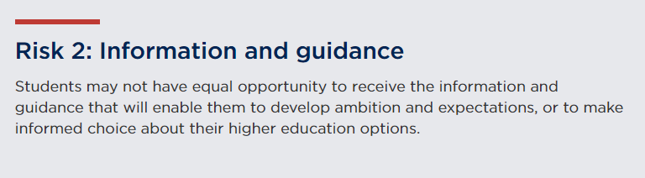
Careerpilot is provided as a free to use, information and guidance tool to all students, schools and Uni Connects in a subscriber’s region and has significant reach in a mainstream school context as it is delivered to all students, usually from Y7 onwards, including to those identified in national datasets and qualitative research to be the most likely to be affected by this risk factor. Careerpilot received 549,000 national users in 22-23 and there are 260,000 users from a range of targeted and non-targeted postcodes who have set up their own accounts on the site to build their Career Tool report.
The site provides resources, information, advice and a three-stage process to support a student’s career journey from Y7 to Y13, providing content and suggested activities that are age-appropriate which show students how to explore their preferences, and their options. Through this, they develop career management skills, improve self-confidence and motivation. The site aims to inspire students to progress further and to understand all routes to higher level study.
The Pathway Planner, which is free to all schools in a subscription area, supports students in choosing their next-stage options and in assessing their readiness to progress in their chosen pathway. The Pathway Planner provides data so that a school can support an individual’s progression needs. A ‘trigger’ in the system will offer students who are definite or considering HE access to support offered through impartial webinars provided by Careerpilot and also by subscribing partners.
Activity for potential inclusion in your APP linked to Risk 2: Information and Guidance.
The University of XX will provide annual subscriptions to offer the Careerpilot information and guidance webtools and the Pathway Planner triage tool free to all students, schools and Uni Connects in their immediate region. The subscription also enables the Careerpilot Team to support students, schools, parents/carers and Uni Connects in making best use of the resources to ensure all young people have access to good quality information and guidance. This activity mitigates the risk that some students may not have equal opportunity to receive the information and guidance that will enable them to develop their ambitions and expectations, or to make informed choice about their higher education options.
Outputs for 22-23 (to be set annually):
- 540,000 users will access the web tools nationally
- 260,000 students in Y10-Y13 will be registered on Careerpilot and have their Career Tools account;
- The majority of all schools with a subscription engage with Careerpilot
- 95 schools will be Super Users
Outcomes:
A majority of student users of Careerpilot surveyed will, through an annual survey report, show they have met the following indictors:
- Understand more about their full range of options;
- Can see HE level as a choice for them;
- Know that achieving the best qualifications can provide more choices in working life;
- Feel better prepared for their future progression;
- Feel they have a useful source of information and support to help inform their progression.
“Careerpilot has been an essential part of my progression into HE. The info. they have provided has been presented in a way that makes it easy to obtain, making the website invaluable for my future career.”

“It helped me decide on my career future and provided useful resources to use and guide me through the possible options.”

“It is so helpful I found such great job ideas and I want to be a worker now its inspired me to get better in school and work harder”

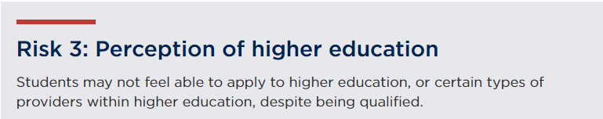
Careerpilot provides information and advice on ALL pathways available to young people and also offers search tools so that users can look for degree level courses and apprenticeships nationally, or look in detail at a providers offer across subscription areas.
The ‘HE at 18+’ section includes information on different types of HE level courses, how to decide which course/provider, and additional information to help students manage progression and be well-prepared for their next step. Content and tools have been developed by qualified career advisers. The site aims to mentor the students as they develop their understanding of self and their options, so they are well-informed and ready to make career decisions to best suit their needs and aspirations.
Through the Provider Search users can use search criteria to find different types of providers and use ‘quick link’ tools to easily explore a provider’s offer. Providers who are subscribers can also add additional information about their specific offer.
In tools offered through the site students can start with their skills, subjects they like, values that are important to them, jobs of interest and research detailed information on how to progress, with ideas of example courses offered by subscribing providers. This enables students to become more aware of the wealth of options and also to explore both what they want to do and where they could do it, nationally, but also with specific examples from subscribers.
Over 1000 video stories in the site provide inspirational and informative content about routes, jobs, barriers and how to overcome them so students can learn from others who have already progressed.
Activity for potential inclusion in your APP linked to Risk 3: Perception of Higher Education.
The University of XX will provide funding to enable Careerpilot to be free to all students, schools and Uni Connects in a subscribers immediate area which will offer easy to use tools that support students in understanding and exploring the range of courses and providers available, and by providing information/advice through written content created by qualified career advisers. Careerpilot also offers users access to 1000s of videos about qualifications and jobs, to support students in managing the decision and progression process to mitigate the risk that students may not have equal opportunity to access a sufficiently wide variety of higher education course types.
Outputs for 23-24 (to be set annually):
- 45,000 students use the Provider Search tool
- 110,000 students use the ‘Start with a subject’ tool which will link with example jobs/courses;
- 15,000 students access video stories to support their understanding of routes, jobs and overcoming barriers;
Outcomes:
A majority of users of Careerpilot will through an annual survey report show they have met the following indictors:
- Know what courses/jobs a subject they like could lead on to;
- Know more than one route into HE e.g degree+1;
- Know what steps to take next to make a successful progression move.
“I know the exact steps and qualifications I need for so many jobs. It is so useful in sorting out a future plan.”

“Careerpilot has really helped me get a better idea of what I want to do in the future and how to get there”

“Careerpilot helped me determine which A-levels are most sought after for my career path.”

Appendix 1: Theory of change 1
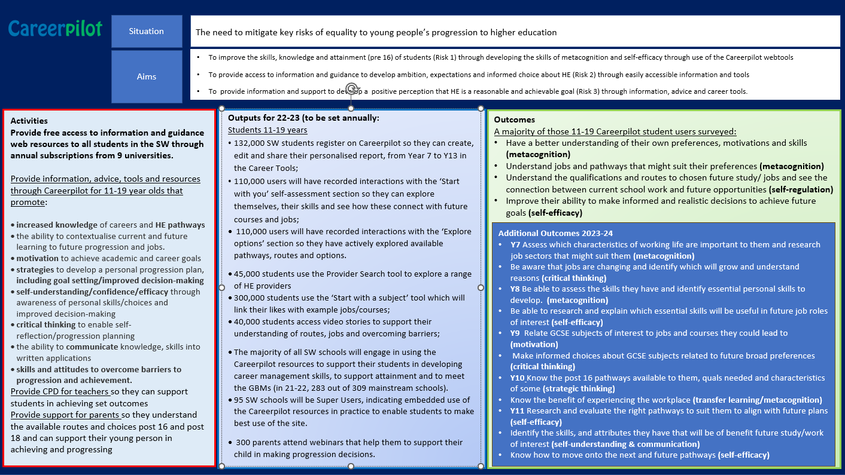
Appendix 1: Theory of Change 2
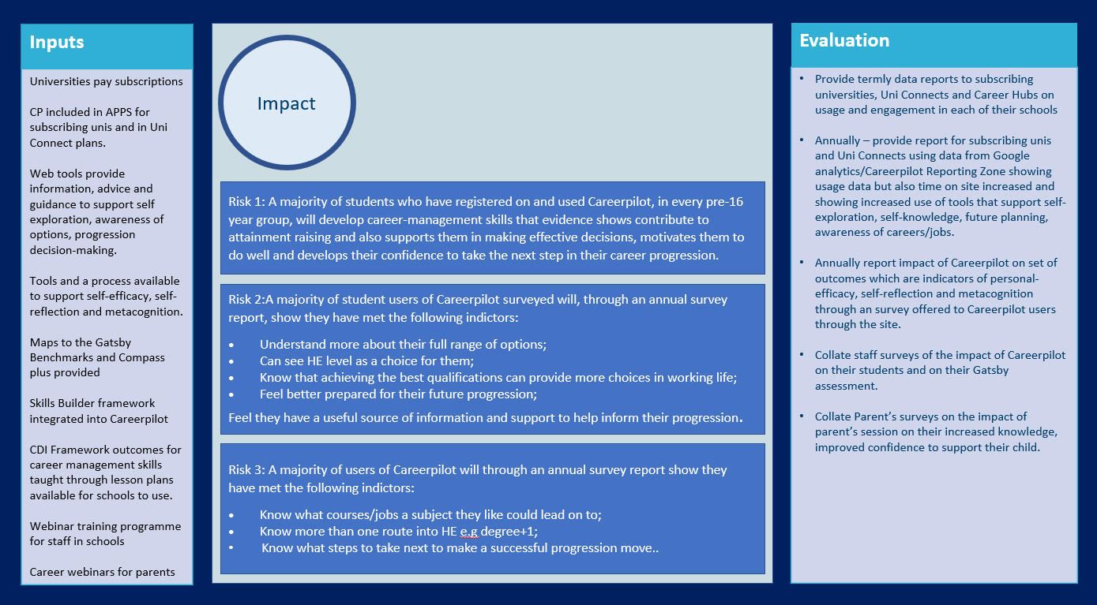

Appendix 2: Evidence that careers supports attainment:
There are various research reports that show the link between good career education information, advice and guidance (CEIAG) and attainment.
In a report written for the Careers and Enterprise company – Personal (career) Guidance What Works? Julia Everitt, Siobhan Neary, Marco Antonio Delgardo Fuentes and Lewis Clark reference the following research:
Reid (1) notes that outcomes can be immediate, such as increased motivation, confidence or a revised job search strategy, or they can be revealed over the long term
However, it is inevitably more challenging to capture and demonstrate long-term outcomes in research studies .
Musset and Mytna Kurekova (2). emphasise that there is empirical evidence which suggests that guidance can have a formative impact on educational, social and economic outcomes for young people. These improvements are generally modest but are ‘driven by increased student motivation linked to a deeper understanding of the relationship between education and employment’ (p.10). Personal guidance can support young people to develop their personal effectiveness, career readiness and better educational outcomes.
- Reid, E.R. (2018). Length Matters! Exploratory Research into the Impact the Shortening of Guidance Appointments is Having on Practice. Warwick: University of Warwick.
- 2.. Musset, P. and L. Mytna Kurekova (2018), Working it out: Career Guidance and Employer. OECD Education Working Papers, 175. Paris: OECD Publishing.
Improved GCSE performance – as a study by a charity in 2019 showed. Those students who had career talks about future jobs were more motivated to study harder and had an improvement in academic attainment.
"This report underlines the value of good careers education which builds confidence, broadens horizons and fuels ambition. Good careers education must be available to as many young people as possible," Education Secretary Damian Hinds
An evaluation of the North East of England pilot of the Gatsby Benchmarks of good career guidance - March 2021 shows the impact on attainment, etc.
The evaluation, carried out by the International Centre for Guidance Studies (iCeGS) at the University of Derby, followed 16 schools and colleges in the North East of England as they implemented a career guidance framework known as the Gatsby Benchmarks. Findings within the report include:
The greater the number of Benchmarks held, the greater the number of GCSE passes at A*-C/9-4 were achieved by each learner, even when gender, ethnicity, SEND status, FSM status, looked after status and Ofsted rating were statistically controlled for. They found - Each additional GBM a school achieves is associated with a 1.4% reduction in rates of Not in Employment, Education or Training. Among the most disadvantaged quarter of schools, the effect is twice as large: 2.8%
Careers in the Curriculum – What works (Careers and Enterprise Company), Jill Collins and Anthony Barnes (The Centre for Development and Research in Education, Sheffield Hallam)
Educational outcomes
Careers in the curriculum can contribute to improvement in attendance, reduced drop- out, attainment and progression to personally valued educational destinations (page 5).
A report by the Sutton Trust found an association between schools that had careers quality awards – the criteria for which include having a careers curriculum, careers guidance and work-related learning – and improved attainment and attendance.2
Improved educational outcomes were also noted in a case-study of the impact of a school’s comprehensive careers programme on student outcomes. The results pointed to improved GCSE results, the virtual elimination of course switching and drop-out from post-16 study and minimal drop-out from higher education (page 6)

Appendix 2:
Indicators of attainment to evaluate the impact of Careerpilot as a tools to mitigate RISK 1: Knowledge and skills:
All pre-16 students
- Have a better understanding of their own preferences, motivations and skills (metacognition)
- Understand jobs and pathways that might suit their preferences (metacognition)
- Understand the qualifications and routes to chosen future study/ jobs and see the connection between current school work and future opportunities (self-regulation)
- Improve their ability to make informed and realistic decisions to achieve future goals (self-efficacy)
Y7
- Assess which characteristics of working life are important to them and see job sectors that might suit them (metacognition)
- Be aware that jobs are changing and identify which will grow (self-efficacy)
Y8
- Be able to identify essential personal skills and assess the skills they have. (metacognition)
- Be able to relate how essential skills will be useful in future work (self-efficacy)
Y9
- Relate GCSE subjects to jobs and courses they could lead to (motivation)
- Make informed choices about GCSE subjects (critical thinking)
Y10
- Know the post 16 pathways available to them and quals needed (strategic thinking)
- Know the benefit of experiencing the workplace (transfer learning/metacognition)
Y11
- Choose the right pathways to suit them and their future plans
- Identify the skills, and attributes they have that will be of benefit to future study/work (self-understanding & communication)
- Know how to move onto the next and future pathways (HE knowledge)
- Improved exam performance (motivation)
- Reduced likelihood of dropping out of post-16 courses (attainment)
- Improved likelihood of Progression to HE (self-efficacy)

