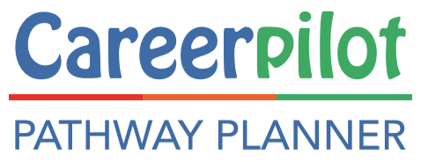
Audience for this case study:
CEC, Career Hubs, Career Leaders/ SLT
Guidance Advisers

Year groups
Y11/Y12/Y13
Focus
Whole school approach
Gatsby Benchmark
3 and 8
Organisation: Careerpilot based at the University of Bath
Project Lead: Sue Lewis
s.lewis3@bath.ac.uk
https://careerpilot.org.uk/
Providing effective, whole-school guidance through a triage model
Overview of the Careerpilot CEC funded project

Careers and Enterprise Company Personal Guidance funding
Overview of Project Case Study
* Pathway Planner—more details of costs
The whole-school, Careerpilot Pathway Planner guidance model, piloted with funding from The Careers and Enterprise Company, aims to:
- Provide a whole-school model for delivering personal guidance that is integrated into the work of the school and supports delivery of Gatsby Benchmarks;
- Prepare students effectively for progression planning and personal guidance;
- Provide personal guidance according to individual needs, through triage;
- Use one source of careers information, advice, reporting and recording - available to student, staff, advisers and parents (Careerpilot);
- Raise the status and value of careers and personal guidance across a staff team.
- Provide a range of wraparound guidance formats to support individual personal guidance e.g. drop-in, eguidance, self or tutor referral.
- Provide a follow-up, after guidance process to engage tutors or similar in supporting students’ progression.
- Explore the research themes: preparation and feedback, integration and space and time (CEC PG: What Works?)

What is Careerpilot?
Careerpilot is a one-stop careers website with information, advice and tools to support 11 – 19 year olds in making informed career decisions. The site includes an Adviser, Parent and Reporting Zone. Careepilot is free to use in the South of England, through co-funding from 20 universities and 6 Uni Connect projects. Careerpilot.org,uk

Arrangements for the pilot:
In 2019-20 the Careerpilot Team based at the University Bath bid to the CEC for funding to pilot a whole-school approach to personal guidance, using triage.
Six schools in the West of England and Swindon &Wiltshire areas were recruited to pilot the Pathway Planner model with 60 Y11s and 40 Y12s. All students received 1:1 guidance and access to alternative guidance formats.
In each pilot school a member of staff was trained in the Level 6 Diploma of Careers Guidance and given one day a week to manage and deliver the project and provide personal guidance using the three-stage process and triage.
Activity detail:
The whole-school model developed through the CEC project – now called the Careerpilot Pathway Planner model is as follows:
- Pre-guidance Option Choice session: All pilot students receive a one-hour structured online session. The session follows a set format using a pre-designed, interactive presentation. It starts with a short “Your Future Career” video, designed with funding from the project, to help students understand how they can manage their own careers. The session facilitator then explains all next stage option choices to the students and allows time for them to explore information about the options they are particularly interested in, using the Careerpilot website. Students use the Career Tools to ‘tag’ options, jobs, courses of interest. For the last 5-10 minutes of the session, students complete the online Pathway Planner Triage Tool, which uses a quiz-based format. Students indicate which options they are interested in, for Y11 - post 16 or Y12 - post 18, and then answer question to assess their readiness for their chosen pathway. The responses determine whether students are given a Red, Amber or Green score, indicating their ‘readiness’ to progress on their chosen pathway.
- Personal Guidance: The Pathway Planner results provide individual and cohort level data on the pathways the students are ‘definitely considering’, ‘considering’ or ‘not considering’ and their level of knowledge and preparedness for their chosen pathways. The results are instantly available to the student/Careers Leader/Personal Guidance Adviser. The Red, Amber, Green score can be used alongside other data (such as predicted grades) to determine the initial level of guidance students will be offered. The Careerpilot pilot model recommended Personal Guidance sessions should be offered with the following timings: Green (20 minutes), Amber (30 minutes) and for Red (60 minutes) which includes all students who may be considering an apprenticeship or have an additional need (additional needs can be tagged in the system). The pre-guidance process and triage ensures the careers adviser has detailed information on the needs of the individual student, through the Career Tools and Pathway Planner reports, before delivering one-to-one guidance. The reports inform the discussion, ensuring the guidance is focused, efficient and addresses individual needs. At the end of the guidance session, action points which are agreed with the student are given to them on a postcard, and then recorded, with a full report of the guidance discussion, on the student’s Careerpilot profile. These are visible to the student and any staff member with access to that student.
- Follow-up: Three to four weeks after the Personal Guidance session, a trained school tutor (or similar) follows-up each student by asking three set questions to check if students are on track with their action points and future decision-making. If any concerns are raised the tutor can refer students for additional guidance.
In addition to the one-to-one guidance session booked after triage, throughout the school year students can also access alternative guidance formats: e-guidance (using an online form), attending a weekly drop-in guidance session, or by self/tutor referral.
The Careerpilot website and its reporting functions underpin the delivery of the Personal Guidance model. Students build an individual timeline in their Careerpilot Pathway Planner which shows their triage results and guidance interventions. They can edit their responses as they develop knowledge and understanding of their chosen options. For example, an initial Red score based on an interest in an Apprenticeship pathway may develop to an Amber or Green because of the guidance and support received. This enables students to see their progress and schools to collate data on how they are meeting student needs. The Pathway Planner reporting functions also enable advisers to book and record sessions through the system.

* Pathway Planner—more details of costs For more information contact careerpilot@bath.ac.uk

How this supports Gatsby:
The whole process provides evidence to meet Gatsby 8, if all students have a one-to-one personal guidance session before 16 and again before 18, delivered by an adviser with a Level 6 careers guidance qualification.
The process and tools also provide evidence for Gatsby 3 - meeting individual needs - as the Careerpilot pre-guidance session and triage determines individual needs, interests and planned pathways and the guidance interventions are provided according to the individual needs of the students.
Impact on student/school/curriculum:
Pilot students completed the CEC Future Skills survey before and after the project (awaiting results from the CEC).
Pilot students also completed surveys following their personal guidance session. They completed different surveys depending on whether they received a 20 minute (green), 30 minute (amber) or 60 minute (red) session. The results showed that the majority of students found the sessions useful, irrespective of the session length.
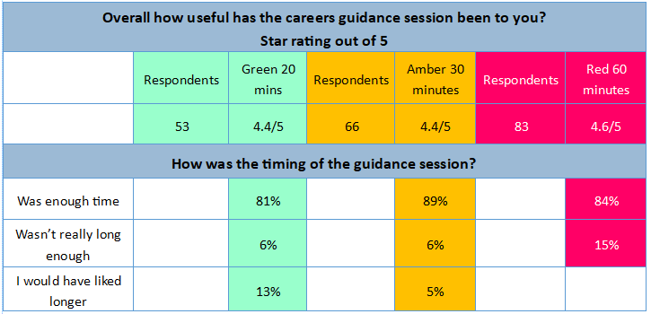

The Pathway Planner Model:
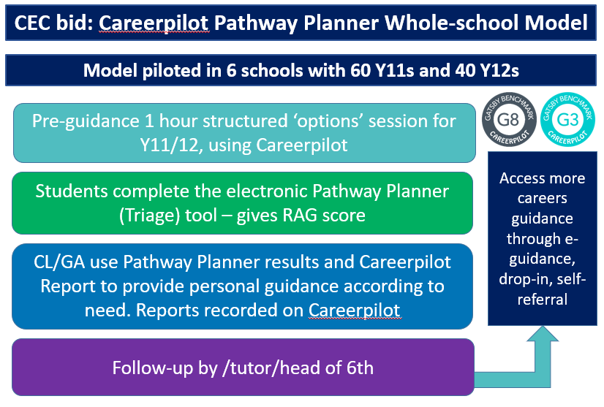

Impact on student/school/curriculum, cont..
A researcher, employed by Careerpilot, evaluated the project through face-to-face interviews with students, project leads and SLT links in all pilot schools. The Interim Research report is now available.
The report provides a detailed analysis of the impact of the Pathway Planner Model, which includes its impact in relation to the CEC research themes as follows:
- Integration: Careerpilot and the Pathway Planner model is being integrated into the school’s strategic career guidance programme. The model is supported by senior leaders, with a wider involvement of teaching staff, and is supporting schools to achieve the Gatsby benchmarks. Several schools indicated how Careerpilot and the project was supporting their work with parents. Having a member of school staff who is now a skilled and qualified L6 Careers Adviser was also significant in a school’s ability to offer a coherent, integrated programme. The benefits of a member of school staff having this qualification ensures they are integrated in the school, have strong relationships with staff and students, and are influential in developing the role of careers within the school.
- Preparation and feedback. The three-stage model ensures that young people are adequately prepared for their personal guidance session. Registering young people on Careerpilot, giving them an opportunity to explore a range of information and complete the Pathway Planner was an effective preparation for the guidance interview. This preparation enabled the Careers Adviser to direct the guidance towards crucial topics. The co-agreement of action points and reporting through Careerpilot has been helping young people to understand their next steps and the involvement of tutors in the follow-up stage is helping to embed careers more broadly within the school community. Capturing data accurately within Careerpilot ensures the school is collating individual and cohort level data which can be shared when appropriate.
- Space and time. Most of the Careers Advisers had been allocated appropriate spaces to work in, although some had experienced issues in gaining access to IT suites. Students were familiar with the careers space and had made use of the drop-in opportunities and e-guidance. The reporting tools in Careerpilot were central to recording all types of guidance and in ensuring schools were effectively monitoring the delivery of Personal Guidance. Furthermore, the reporting tools enabled Career Advisers to prioritise different groups of students, such as those with few career ideas or plans. Regarding the time available for Personal Guidance, the triage tool was viewed as helpful with guiding the time allocation and ensuring the Career Adviser was prepared for the guidance discussion.

“The triage tool was really helpful. Last year I came in and I just saw students 1 on 1. This year, I did the Careerpilot pre-guidance session with every single year 11 in their PSHE lesson. (only pilot’s used the PP triage). Hugely helpful, and I was like ‘How come I didn't think of this on my own?’ Because I used to meet the person and I was repeating the exact information over 200 times.” Career Adviser

It has been a great way for us (tutors) to get to know our tutees more in terms of what career paths they would like to choose, so thank you for picking us as tutors! 😊 It is always great for me to learn my way around new software too, as I am a technophobe, so knowing how to use Careerpilot is a new skill for me! so thank you! Tutor
“Historically, we hadn't been too strategic. We'd been strategic in the sense of targeting students who we thought were at risk in terms of needs and pupil premium but after that it was quite ad hoc. We certainly didn't have any kind of sense of how much support or input they needed. So, from our point of view, as a school, it was really useful to have a system like this where you can see where students are in terms of their career guidance, how much they probably need. The Pathway Planner for us is fantastic. It is a really useful strategic tool for me as a senior leader. I think it allows [the careers adviser] to use her time in a more impactful and more focused manner. I know as a school we would definitely be keen to carry on with Pathway Planner.” SLT Lead

“ We have just done our Y11 destination survey and there’s only about four or five kids that have not got an idea, which is so different from normal.” Head

“Being part of this project has helped me to understand what I am going to do in the future and made me feel relieved and more confident.” Year 11 student
“I feel more assured are of my next steps to get where I want to be.” Year 12 student
Top tips for anybody deciding to sign up to use the Pathway Planner model
Tip 1: Get SLT, Career Leader, Level 6 Adviser and tutor team buy in, by showing the benefits and impact of the Pathway Planner;
Tip 2: Ensure your school/college has access to Careerpilot and the Reporting Zone so you can set up groups and see reports;
Tip 3: Before the pre-guidance session get students registered on Careerpilot so they have an account and can be set up to access the Pathway Planner (just a 20 minute quick intro to Careerpilot and get registered session would do);
Tip 4: Schedule sessions in an IT room, at an appropriate time for the students in their decision-making process, of one hour, for all students who will be receiving the pre-guidance session which will include using the PP;
Tip 5: Allocate time to analyse results and book guidance sessions according to need (remember one session before 16 and one after to meet Gatsby 8 with a L6 adviser);
Tip 6: Record all bookings on the Careerpilot Pathway Planner so that the interventions are logged on the student’s Pathway Planner timeline;
Tip 7: Record all guidance reports and action on the Careerpilot Reporting Zone so they can be seen by the students and any staff with access;
Tip 8: Give tutors or those doing follow-up access to Careerpilot so they can see the Career Tool and Pathway Planner report and add follow-up outcomes (takes 5 minutes per student). Train tutors (25 mins) to ask the 5 follow-up questions and log student responses on Careerpilot.
Tip 9: Set up evaluation to monitor the impact of the Pathway Planner model and guidance on students, tutors and other school outcomes.
Tip 10: Share Careerpilot Reports with parents.

How we are adapting/developing the Pathway Planner model:
The Pathway Planner model has achieved the aims and outcomes set. Some pilot schools have been able to use the reports from students completing the Pathway Planner to identify gaps in the careers education and information they are providing to their students e.g. in one school they realised they need to do more in Y10 on apprenticeships, in another that they needed to explain the props and cons of gap years to Y12.
Some pilot schools plan to offer pre-guidance sessions in Y10, leading up to students completing the Pathway Planner triage tool in Y11 before guidance. Some schools plan to offer the pre-guidance and Pathway Planner session to Y12 later on in the school year (the project required them to do this before Easter).
The Pathway Planner tool has now developed further to offer additional functionality e.g. a guidance adviser can add additional details about a student’s planned destinations and tutors can record follow-ups on the system.
The Pathway Planner is now being made available to other schools for a small fee. The fee includes access to all materials and tools, training - which explains the good practice models developed through the pilot – and membership of a user group, which will share resources, models, good practice and contribute to developments.
More detail of how schools can request access and dates of free introductory webinars here .
Additional Quotes:
If you would like further information about the Careerpilot Pathway Planner model or would like to attend a free webinar to find out more then follow this link or contact Sue Lewis s.lewis3@bath.ac.uk
From students:
“It [the guidance session] introduced me to the jobs I can take with the subjects I choose and gave me a range of information about my next steps” (Year 11 student)
“I really like the range of ideas provided in terms of jobs as well as the qualifications needed.” (Year 11 student)
“It has given me a clearer understanding of my future paths but also made me more aware of more opportunities.” (Year 11 student)

“It has allowed me to further explore options I didn’t even know existed.” (Year 12 student)

“I feel more confident in moving forward and making decision for my future now I have all the information.” (Year 12 student)
Career advisers:
“ I have found it [the pathway planner] really useful with the ‘grey student’; the ones with no major issues who are just floating along. I had one in particular, who is a really bright student, and everyone just assumed that she’d go to sixth form but she just had no idea and the Pathway Planner helped to identify that. I was able to bring her in, and it was just knowledge she needed about her options. That’s one thing which I think has been a huge success.”
“The Pathway Planner itself, I'm very pro. What I like about it is it gives me some preparation material that allows me to have a conversation. ‘Let's talk about what you thought about University, what you thought about employment,’ and I think that’s a really good icebreaker. Do I use it as a reference point? Yes. Do I expect it (the PP) to change after we've had our conversation, a hundred percent. And it does because I've given them more information. I think the kids have quite enjoyed thinking about it because it's probably the first time they've had all their options in front of them.”
“The Pathway Planner tool did enable me to prioritise my time. I could look at the tool, I could see who had additional needs. I could to some extent see which students were more likely to turn up for their interviews and schedule them at the beginning of the day or week. It just helps with time management. When you know you have other things and only half a day to make progress you can slot in a lot of greens and then, you can manage your own workload. That’s more job satisfaction and you can manage your productivity a little bit better.”
From SLT:

“The thing that impressed me is the quality of the website [Careerpilot]. To have all that information in one place and the routes it takes you down is really helpful.... But also having the reports, for us we realised we have some really bright students that are really anxious that they are not going to get the qualifications they need to go on to A Levels. What that means is that we can be proactive and intervene. It has been very helpful for me to see those overall reports.”

“It gives it (careers) coherence. If they've done it in Year 11 they'll have the records of what they've done for Y12, instead of schools having to start every year fresh, they can see where they've made shifts. I think young people don't think ahead in years, so, I think anything that helps them see (career planning) as the long game, has an impact on us being able to monitor the impact we have, through the one-to-one guidance.”

“It's being able to hit whole cohorts so it's important that we don't lose anyone. Having a structured program and having that data to back it up so we can look at impact and we can think about where we go in the future with those students has been really important. It's great when you can get a whole cohort doing something.”

“The reason I like Careerpilot (and the Pathway Planner) is because it's for the students. It's not one of these systems that administrates for the staff to find destination data, but actually about what's the kids get out of it? It's more about the kids taking ownership of their own pathway.”

